Chapter1
1. Introduction
With the growth of multimedia systems in distributed environments, the research of multimedia security as well as protection of digital multimedia content has become an increasingly important issue for content owners and service providers. Copyright protection whole 3 watermarking schemes are used: Spread Spectrum, Scalar Costa Scheme Quantization Index Modulation, and Rational Dither Modulation.
1.1 Problem Statement
In recent years, many watermarking schemes have been developed. In all frequency domain watermarking schemes, there is a conflict between robustness and transparency. If the watermark is embedded in perceptually most significant components, the scheme would be robust to attacks but the watermark may be difficult to hide.On the other hand, if the watermark is embedded in perceptually insignificant components, it would be easier to hide the watermark but the scheme may be least resistant to attacks.
1.2 Objective
The objective of our project is to embed the watermark (invisible watermark), in all the frequency bands of a cover image, before distribution or transmission and to successfully extract the watermarked data though it is passed through different types of attacks.
1.3 Methodology
By taking a cover image we are decomposing it into sub images using wavelets, then the.
1.4 Scope of study
Digital communication has become an essential part of infrastructure nowadays. A lot of applications are Internet-based and in some cases it is desired that the communication be made secret. Computer technology and the internet had made a breakthrough in thetransmission of information. It has also opened a new way of applying watermarking using
1.5 Limitations and impacts on the digital age
In this decade, the Internet especially the World Wide Web a global working network with worldwide broadcasting potential has been successfully integrated into public and business domains. Recent surveys and public opinion polls have accented the value of the Internet. In addition, the growth and integration of broadband access points, wireless and mobile technologies and the progress towards one-in-a-box device proves the significance of developing a legitimate marketplace for entertainment and business activities.
1.6 Existing system
One of the weaknesses of all encryption systems is that the form of the output data (the cipher text), if intercepted, alerts the intruder to the fact that the information being transmitted may have some importance and that it is therefore worth attacking and attempting to decrypt it. This aspect of cipher text transmission can be used to propagate disinformation, achieved by encrypting information that is specifically designed to be intercepted and decrypted. In this case, system assume that the intercept will be attacked, decrypted and the information retrieved.
1.7 Proposed system
This system presents a method of hiding encrypted information in a color digital image. In principle, any cipher can be used to do this providing it consists of floating point (or decimal integer) numbers that are ideally, uniformly distributed. The scheme allows for the authentication and self-authentication of documents such as letters, certificates and other image based data. We investigate in detail the embedding capacity, Robustness, perceptual quality and security of the proposed algorithm, using these watermarking schemes: Spread Spectrum (SS), Scalar Costa Scheme Quantization Index Modulation (SCS-QIM), and [2]-[5], where the owner of media, distribute the media in compressed and encrypted format to consumers through multi-level distributor network.
There have been several related image watermarking techniques proposed till date [7]-[12]. In [7], Deng et al. proposed an efficient buyer-seller watermarkingprotocol based on composite signal representation given in [8]. However, when the content is accessible only in encrypted form to the watermark embedded, the embedding scheme proposed in [7] might not be applicable as the host and watermark signal are represented in composite signal form using the plaintext features of the host signal and in [7], this is possible as the seller embeds the watermark. Also, there is a cipher text expansion of 3.7 times that of plaintext.
In [9], some sub-bands of lower resolutions are chosen for encryption while watermarking the rest of higher resolution sub-bands. While in [10] encrypted domain.

Chapter 2
2. Literature Survey
S.O. Hwang et.al [2], proposed in order to ensure the security of datatransmission, the data is usually encrypted before it is released through network, but this method does not prevent being copied illegally after data decrypted and cannot prove that the data belongs to the original owner after being replicated illegally, therefore the encryption method cannot achieve the purpose of copyright protection perfectly. In order to protect the digital content copyright effectively, digital watermarking technology is proposed.
A Sachanet.al [3], proposed traditional digital rights management (DRM) systems are only two party systems, involving the owner and consumers. However, for scalability of business it is often necessary to involve additional levels of distributors and sub-distributors, who can promote and distribute the content in regions unknown to the owner. Thus, we propose architecture for multiparty multilevel DRM system.
T. Thomas et.al [4], proposed multiparty multilevel digital rights management (DRM) architecture involving several levels of distributors in between an owner and a consumer has been suggested as an alternative business model to the traditional two-part(buyer-seller)
Denget.al [7], proposedBuyer-seller watermarking protocols integrate watermarking techniques with cryptography, for copyright protection, piracy tracing and privacy protection. In this paper, we propose an efficient buyer-seller watermarking protocol based on homomorphic public-key cryptosystem and composite signal representation in the encrypted domain.

Chapter3
3. Proposed Design
In digital rights management (DRM) systems, digital media is often distributed by
3.1 Block diagram
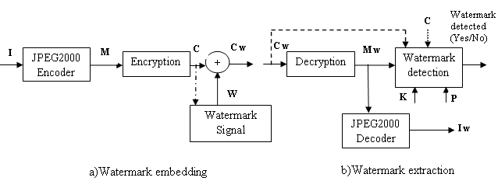
Fig.3.1.Basic block diagram
Notations:
• L= Length in bytes.
• M=Compressed byte stream
• Mw=Watermarked copy of M.
• C=Encrypted copy of M.
• Cw=Watermarked copy of C.
• b=Watermark information.
• E(.) and D(.)=Encryption and decryption function.
• K=Encryption key.
• r=chip rate in SS.
• α = Watermark strength factor in SS.
• P=PN sequence with zero mean and variance .
• Kqim=Random sequence.
• β = Scale parameter in SCS-QIM.
• Δ = Step size.
• q=Denotes the quantization error sequence.
• Lm=Number of the past watermarked samples in RDM
• γ = Shape parameter in RDM
• I,Iw =original and watermarked decompressed image.
3.2 Modules
- Watermarking Domains
- Compressed Domain Watermarking
- Encrypted Domain Watermarking
- Watermarking Retrieval
- Five Stages of JPEG2000 Compression
- Watermarking Schemes to Compressed Encrypted Stream
- Data Embedding
3.2.1 Modules description
3.2.1.1 Watermarking Domains
A) Compressed Domain Watermarking
In this module, a small modification in the compressed data may lead to a considerable deterioration in the quality of decoded image. Thus the position for watermark embedding has to be carefully identified in the compressed data, so that the degradation in the perceptual quality of image is minimal.
B) Encrypted Domain Watermarking and Watermarking Retrieval
In this module, in an encrypted piece of content, changing even a single bit may lead to a random decryption. Therefore the encryption should be such that the distortion due to embedding can be controlled to maintain the image quality. It should also be possible to detect the watermark correctly even after the content is decrypted. Also, the compression gain should not be lost as encryption may lead to cipher text expansion.

Chapter 4
4. Algorithm Implementation
4.1Encryption algorithm
JPEG2000 gives out M, a packetized byte stream as output. In order to encrypt the message M, we use RC6 encryption scheme. RC6 algorithm has a modified Feistel structure and presented symbolically as RC6 w/r/b. w means 32 bits as the size of word, r denotes the number of round. If the size of block is 128 bits, then r, the number, is 20, b means 16 byte as the number of a key.The operations used in RC6 are defined as followings. In cryptography, RC6 (Rivest Cipher 6) is a symmetric key block cipher derived from RC5. It was designed by Ron Rivest, Matt Robshaw, Ray Sidney, and Yiqun Lisa Yin to meet the requirements of the Advanced Encryption Standard (AES) competition. The algorithm was one of the five finalists, and also was submitted to the NESSIE and CRYPTREC projects. It is a proprietary algorithm, patented by RSA Security.

Chapter 5
5. Results And Discussions
Experiments have been carried out for a grayscale image of size 512X512.The PSNR of the watermarked and watermark detected images using the three watermarking schemes Spread Spectrum (SS),Scalar Costa Scheme (SCS-QIM) andRational Dither Modulation (RDM) are calculated and the performance of the three techniques is analyzed.Table 5.1 shows the PSNR of the watermarked images using three watermarking schemes SS,SCS-QIM,RDM are calculated and the performance of the three techniques are analysed.Table 5.2 shows the PSNR of the watermark detected images using three watermarking schemes SS, SCS-QIM,RDM are calculated and the performance of the three techniques are analyzed.
Thus from the results we can conclude that the RDM scheme of watermarking provides better image quality with higher value of PSNR.PSNR can be calculated using the following equation
PSNR = 10*log10(255^2/MSE)(Equations, table and block diagram should be typed don’t do cut paste)
Where Mean Square Error (MSE) is given by
MSE = (1/m*n)*sum(sum(I(i,j)- I_{w}(i,j))^2)
Where I is the original image and Iw is the watermarked image.
Scheme | Peak Signal to Noise Ratio (PSNR in db)
SS | 11.10
SCS-QIM | 10.83
RDM | 12.19

Table 5.1.PSNR (db) for image of size 512X512 watermarked image

Scheme | Peak Signal to Noise Ratio (PSNR in db)
SS | 10.62
SCS-QIM | 10.36
RDM | 12.76

Table 5.2.PSNR (db)for image of size 512X512 watermark detected image

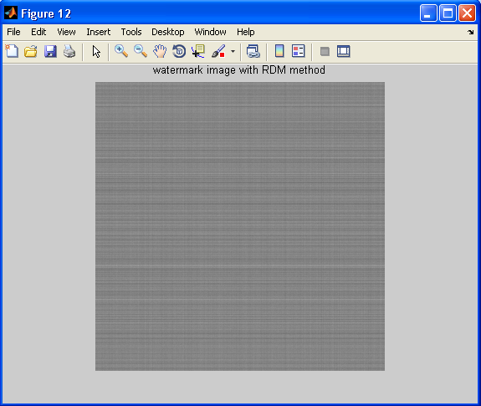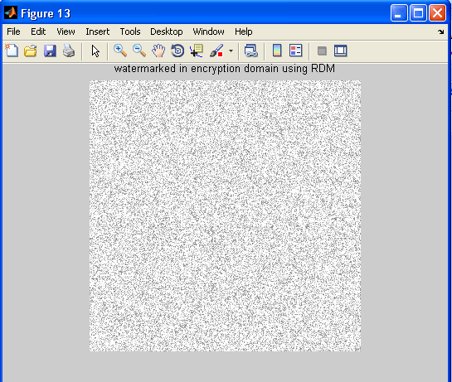
Fig. 5.11. Watermarked image for RDM Fig. 5.12. Watermarked image in
encrypted domain for RDM

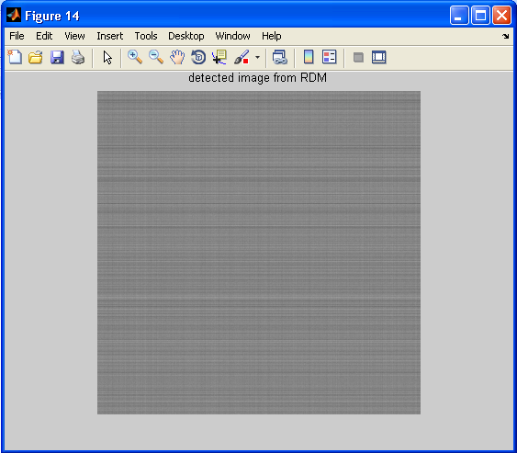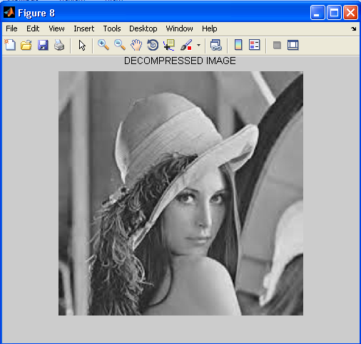
Fig. 5.13. Watermark detected image Fig. 5.14. Decompressed image
domain for RDM method
5.2 Discussions
5.2.1. Key stream generation
The key stream is generated at the encryption and decryptionsite using RC4 cipher. For encryption, a secret seed S isapplied to RC4 cipher which in turn generates the key stream K.In order to generate the same key K at the decryption site, theseed S must be delivered to the decryption site through a secret channel. Once the seed S is received, it can be applied to RC4cipher to generate the key stream K.

Chapter 6
6.Applications
Watermarking can be really useful in several areas of interest involving digital images. In order to fully understand the main challenges involved in the development of watermarking related tools, some applications of invisible watermarks are as follows.
- Fingerprinting
In order to trace the source of illegal copies the owner can embed different watermarking keys in the copies that are supplied to different customer. For the owner, embedding a unique serial number-like watermark is a good way to detect customers who break their license agreement by copying the protected data and supplying it to a third party.

Chapter 7
7.Conclusion And Scope For Future Work

